MCCT’s Matrix² Conferencing Using Aculab Resources

I. Introduction

Historically, MCCT has provided Conferencing Applications to its customers for the past ten or more years. Initially, MCCT conferencing relied on Dialogic MSI boards to provide the conferencing resources and as technology advanced, changed to the Dialogic DCB series of boards. While the conferencing functionality and performance was good, there was room for improvement. Conference sizes were limited to a maximum of 32 conferees and with more people in the conference, the voice quality was not as clear as with smaller numbers in the conference.

Through extensive research, MCCT discovered Real Time Systems, Inc. (RTSI) who had an ISA conferencing board series – The Vendetta boards. These conferencing boards allowed for larger conference sizes and no degradation of voice quality and were soon replacing the Dialogic boards. MCCT conferencing applications, as a result, had significant improvement in the voice quality (echo cancellation) and in the flexibility of conference sizes with no degradation in larger conferences.

The Dialogic and Vendetta boards were ISA boards using the Signal Computing System Architecture (SCSA) bus. The SCSA bus encompasses:

- ISA slot plug-in;
- 1024 time slots;
- 2 MB throughput;
- Clocks from 1st span and
- 26-pin bus.

The Aculab boards are PCI High-density and use the H.100 architecture that supports:

- PCI slot plug-in;
- 4096 time slots;
- 8 MB throughput;
- Clock redundancy and
- 68-pin bus.

It can be easily seen from the above comparisons that the H.100 bus architecture is four times faster and has quadruple the capacity of the SCSA bus. This results in much clearer and crisper voice quality for MCCT’s Matrix² Conferencing. While the older versions of conferencing are still supported, the new Aculab platform is MCCT’s plan for new systems.

II. Hardware Overview

Aculab’s voice resource boards are made up single, dual or quad T-1/E-1 modules with additional Sharc modules available: there can be 1, 2 or 4 Sharc modules on a board – each providing a maximum of 64 voice resources, depending on the features used. For a quad board with 96 channels for T-1 and 120 channels for E-1 there are criteria for determining how many voice resources are required. These are (assume quad boards):

Feature Resources per Sharc

Play/Record w/DTMF 64
Conferencing 64
Speech Recognition and DTMF 64
Speech Recognition w/Barge-in & DTMF 25
Fax Send 46
Fax Receive 12

For a system with 96 ports (92 assuming ISDN where the D-channel is not counted) being used for conferencing, standard Play & Record with DTMF and Speech Recognition and DTMF, 276 voice resources would be required if the system were full and every feature was being used simultaneously. Since not all features will ever be used simultaneously, fewer resources are required. As an example, when a caller is in a conference, Speech Recognition is not be used and vice versa. The more accurate estimate of maximum resources used at a given time is 184. In this situation, three Sharcs equaling 192 voice resources is a better estimate, but four Sharcs would provide a comfort zone where one Sharc could be dedicated to conferencing only and conferencing could be shared with other features on another Sharc. This would effectively provide a dedicated 60 to 64 resources on one Sharc and 30 to 32 on a shared Sharc. The Matrix² daemon looks at the Sharc “load module” log for each Sharc so that these modules can be used in the Conferencing configuration table(s). All resources are shared on the H.100 bus.

Now that the resources required for a specific system and its applications have been described, the Matrix² Aculab conferencing capabilities can be addressed. The voice resource discussion above is included to demonstrate the architecture of the Matrix² conferencing model.

The Matrix² conferencing commands are included in the Matrix² User Manual in Chapter 4, which is appended to this document. The remainder of this white paper describes the Matrix² Aculab Conferencing features, commands and functionality. You may reference Appendix A, Matrix² User Manual, Chapter 4 for more detailed descriptions of each command.

III. Conferencing Commands and Features

A. Command Overview

There are eight commands in the Conferencing Command Group. These are: EAVESDROPCONF, GETFREECONF, NAMECONF, NUMOFCONFEREES, PLAYINCONF, PLAYTONECONF, PUTINCONF and SC1ON1.

EAVESDROPCONF. This command, given its name, is an administrative command for supervisors and monitors only. Its purpose is to allow for training of new operators, ensure that customers are treated properly or some other function of the host company. This is a “listen only” command and the monitor may not be heard.

GETFREECONF. When callers first dial in, they can be placed in the first available conference as determined by this command. It defines what an empty conference is (with or without an Operator/Agent), whether an Operator/Agent is required and if the caller must fall into a specific group or is eligible for all conferences.

NAMECONF. The only purpose for this command is to provide a unique name for each conference; this is useful in reviewing reports on conference activity so that statistics relate to individual conferences rather than the total of all conference proceedings.

NUMOFCONFEREES. As a complement to the NAMECONF command, this command allows for the recording of several statistics, including the number of conferees in each conference, for creating reports. Information that can be set up with this command includes: Total Operators, Total Agents, Total Seats in Use, Caller Category, Supervisors, Number of Eavesdropping Callers and Normal Conferees. Please refer to Appendix A for more a detailed description of these titles.

PLAYINCONF. This is a very straightforward command that allows for playing messages to the caller before entering a conference and/or playing messages to the callers in the conference. Messages to the caller outside the conference can be in the form of announcements (“You are about to enter conference xyz”) and messages to the callers in the conference can be announcing a new caller, ads or whatever is appropriate.

PLAYTONECONF. Instead of playing a message to announce a caller as discussed in the PLAYINCONF command, this command allows for a tone to be played on entry to any conference. Tones for entrance and exit may also be called on with the PUTINCONF command, but this command is universal for all conferences.

PUTINCONF. This is the workhorse command of Matrix² Conferencing and is the command that sends the caller to the destination conference. With this command, callers can be categorized with attributes such as coach, pupil, muted or in a broadcast setting. A caller can also have special flags including normal, agent, operator or supervisor. When a caller is alone in a conference, the determination of music being played or not is made here. Entrance and exit tones (to the conferees) are also decided here. Detailed descriptions of each function in this command can be found in Appendix A.

SC1ON1. This is another versatile command that allows two conferees to speak privately in a two-party conference. Some of the features include storing the port number of the other caller, setting up messages, determination of music messages, wait times and exit keys.

Figure 1 is a flow chart showing a sample of how these commands work together in a conferencing Plan.

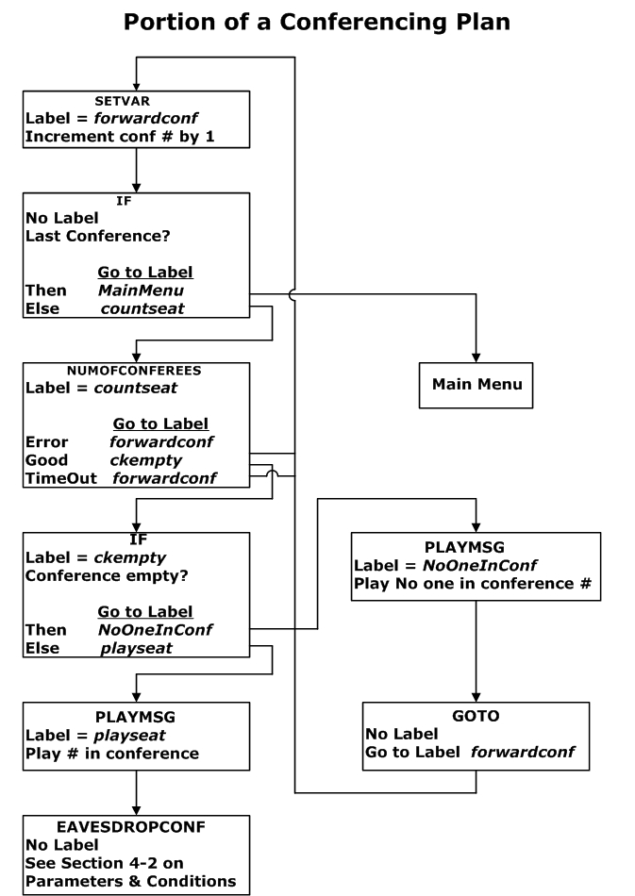

Figure 1. Sample Flow Chart of a Conferencing Plan.

B. Command Structure

All Matrix² commands are based on MySQL Tables. In the Plan Editor, There are 22 Parameter columns where some contain values, expressions, Linux commands or variables. These parameters map directly to command tables in the “matrixplandb” database. Figure 2 shows the Plan Editor screen where the first three parameter columns may be seen.

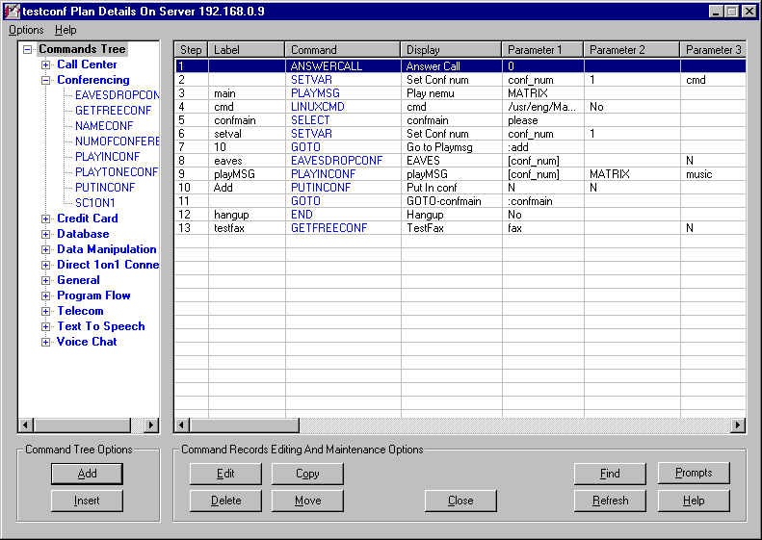
Figure 2. Plan Editor Screen with First 3 Parameter Columns.

These parameter columns correlate to columns in the MySQL database tables and are considered the “back-end” data structure. The table structures are set independently of any command screen. Since the database source must work for all commands and their corresponding screens, there is no one-on-one correlation in the mapping. Each command will have a different mapping scheme.

Figure 3 shows the PLAYINCONF command screen where Parameters 1, 2 and 3 from the Plan Editor screen in Figure 2 can be mapped to the fields in the command screen.

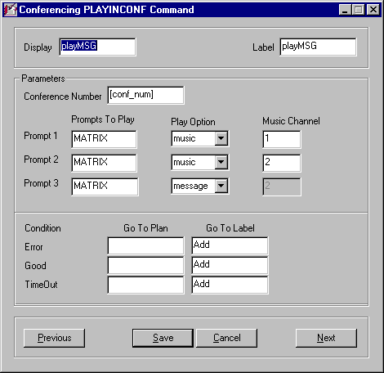
Figure 3. PLAYINCONF Command Screen.

IV. Summary

The MCCT Matrix² Conferencing application is a unique combination of resources for fluid conferencing channels on a Linux/Aculab platform and easy-to-use commands based on a MySQL foundation. Both Linux and MySQL are open source, non-proprietary software environments that adds reliability and high performance since neither is competitive. Linux has been proven to have high security standards and MySQL is limitless in its ability to handle huge volumes of data in a streamlined data flow.

MCCT has used these powerful tools in combination with Aculab’s feature-rich and highly reliable voice boards to result in a Conferencing application that compares to no other. The uses for MCCT’s Matrix² Conferencing are only limited by one’s imagination. For more information, contact MCCT at (800) GO 4 MCCT in the domestic US, (603) 524-2214 internationally or at info@mcct.com.

Appendix A – Chapter on Conferencing from Matrix² User Manual

4-1. Introduction to Conferencing Commands

Conferencing commands provide the ability to put people in a number of conferences with up to 64 people in one conference and the possibility of having 240 conferences. The maximum number of callers is 480 on a system, at this time, so the conferencing setup (MCCT Matrix² Conferencing Setup Manual) is a mix of the number of conferences and the number of callers in each conference.

Eight commands reside in the Conferencing Command Group. These include the following: EAVESDROPCONF, GETFREECONF, NAMECONF, NUMOFCONFEREES, PLAYINCONF, PLAYTONECONF, PUTINCONF and SC1ON1. Figure 4-1 shows the Conference Command Group Drop-down menu.

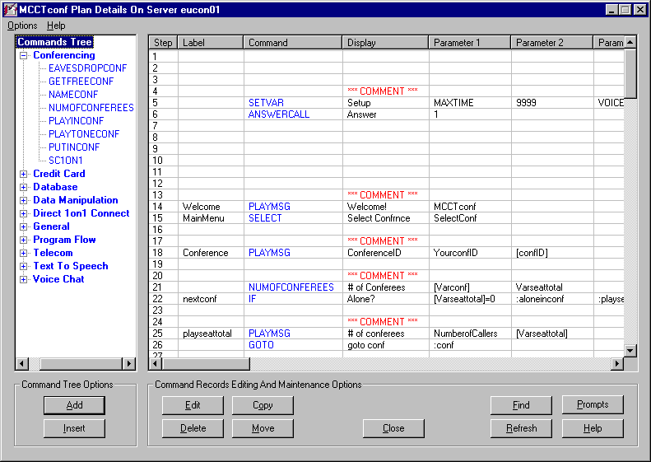
Figure 4-1. Conferencing Command Drop-down

4-2. EAVESDROPCONF Command

The EAVESDROPCONF command is for those administrators or operators whose function is to monitor conference activity to ensure that everyone is playing by predetermined rules. There are several parameters and conditions that the Plan author may set up based on the objectives of the Plan. Keep in mind that the Plan written for the monitor will be different than the Plan that the conferees are calling. Figure 4-2 shows the EAVESDROPCONF command screen.

The Display field is for using a unique mnemonic for the command and its purpose and can be viewed on the Runtime Line Display while the call progress is watched. With the Label field filled in you can jump to this command with a SELECT or other Program Flow command from any Step in the Plan as long as the Label is unique.

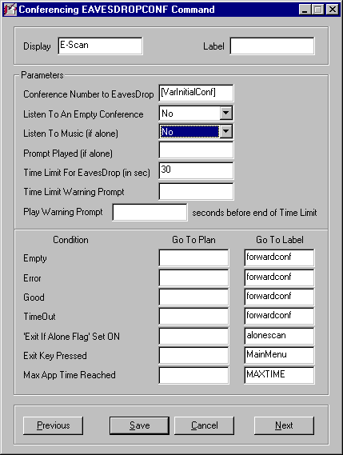
Figure 4-2. EAVESDROPCONF Command Screen.

Parameters

In the Conference Number to Eavesdrop field it would not be advisable to put in a fixed number unless you had conferences that were chosen using a SELECT command leading to several EAVESDROPCONF commands. In this field a Plan Variable should be used (in brackets since it will be used in the command). In this command sample, the variable is shown as [VarInitialConf]. To see how this is used, look at the SETVAR command in Figure 4-3. The variable is set to be an expression where each time this EAVESDROPCONF command is traversed by the caller, the conference number is incremented by “+1”. Each caller is tracked through the command by the conference ID number that is created earlier in another SETVAR command shown in Figure 4-4. Thus, the incrementing of conference numbers is done uniquely for each caller based on the port they called in on.

Please note: Commands from other chapters are used here to show the flow, explain the logic and to help the reader to better understand the use of commands in a Plan. The use of variables, line numbers, expressions, Labels and much more are all an integral part of writing a Plan.

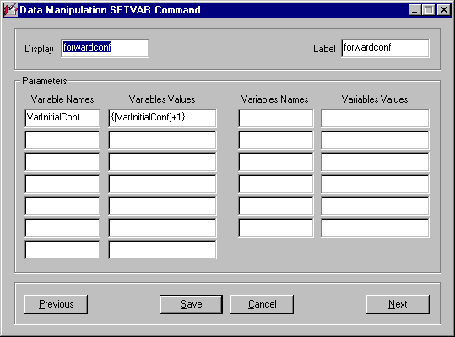
Figure 4-3. Setting a Variable as an Expression.

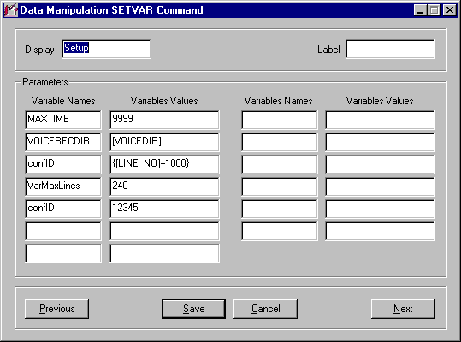
Figure 4-4. Creating Uniqueness for Each Caller

Figure 4-5 is a portion of a conferencing flowchart showing the steps used to instruct the caller or monitor and route him/her through the Plan. Note that sequential steps may not need a Label. Each command screen in the flowchart will be shown in the next few pages.

Figure 4-5. Portion of a Conferencing Flowchart.

In the flowchart the SETVAR labeled forwardconf is followed by an IF command with no Label. Figure 4-3 shows the SETVAR and Figure 4-6 shows the IF command. The IF command gives the possibilities of Then, meaning the monitor has arrived at the last conference, or Else which indicates it is not the last. For either condition, the flow goes to the respective Labels – MainMenu (command not shown here) or countseat – a NUMOFCONFEREES conferencing command shown in Figure 4-7.

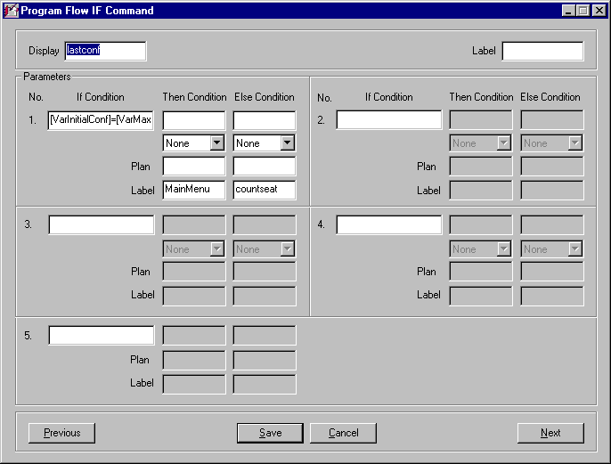
Figure 4-6. IF Command to Determine Last Conference.

In the NUMOFCONFEREES command there are three conditions: Error, Good and TimeOut. These are set to go to the Labels forwardconf, ckempty and forwardconf, respectively. The first and third will go back to the SETVAR to look at the next conference. The Good – ckempty will go to another IF command, Figure 4-8, to check for the conference being empty (a “0” in the NUMOFCONFEREES command) and if not, continue the flow.

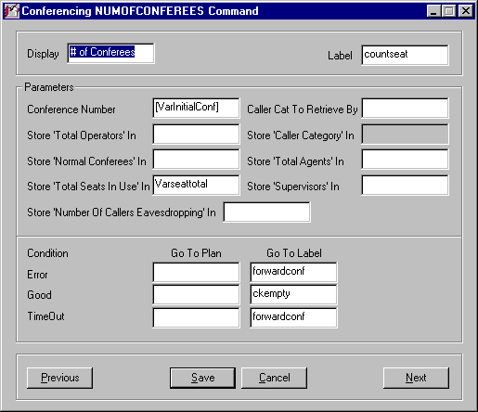
Figure 4-7. NUMOFCONFEREES Command Screen.

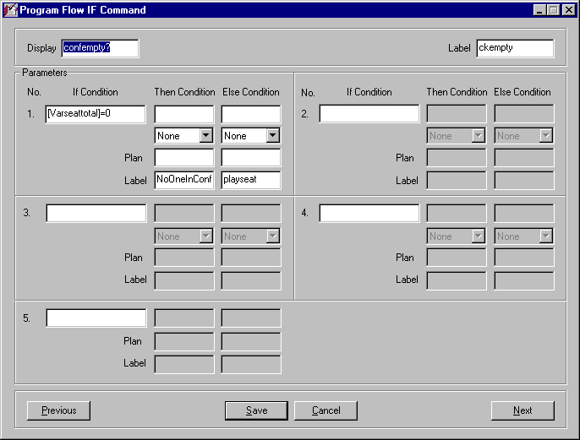
Figure 4-8. IF Command to Check if Conference Empty.

If the conference is empty, the Then condition applies and the Plan flow will go to the Label NoOneInConf that is a PLAYMSG command to inform the monitor (or caller) that there is no one there. This is followed by a GOTO command that will redirect the flow to the “increment by +1” SETVAR command; this will let the caller look at the next conference. Figures 4-9 and 4-10 show the PLAYMSG and GOTO command screens.

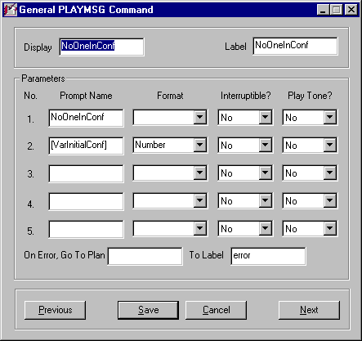
Figure 4-9. PLAYMSG Command Screen with NoOneInConf Label.

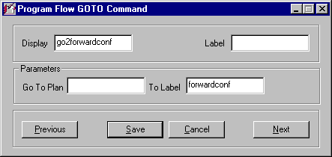
Figure 4-10. GOTO Command to forwardconf.

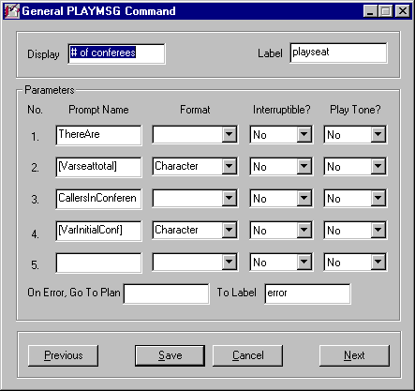
Figure 4-11. PLAYMSG Command with playseat Label.

If the conference is not empty, the Plan flow in the IF command goes through the Then condition to the Label playseat. This is a PLAYMSG command (Figure 4-11) that tells the monitor how many are in the conference. Next is the EAVESDROPCONF command (Figure 4-2) that is the primary topic of this Section. The balance of this Section will be discussion on the remaining parameters and conditions in this command.

The inclusion of the partial flowchart and general commands is for the benefit of those who will be writing Plans. Examples in many cases are a better portrayal of how things work than mere discussions of the working components.

In the Listen To An Empty Conference field the options are “Yes” or “No”. Typically the “No” will be the choice here, but a monitor may want to “sit” in the conference and wait for callers to come in so that the first one to enter will not be “alone”. This option is up to the Plan author.

While a caller is waiting in a conference for the second person to arrive (this is the “alone” status), you have the option of letting them listen to music. In the Listen To Music (if alone) field, select “Yes” or “No” from the drop-down box.

In addition to music (or instead of the music) for the “alone” callers, you may play them a message telling them that they are the only one in the conference and there will be a (short) wait for the next conferee. Put in the voice filename or Plan Variable (in brackets) in the Prompt Played (if alone) parameter field.

You may allow a monitor a predetermined amount of time to listen in on a conference. In the Time Limit For EavesDrop (in sec) field, enter the time in seconds to allow for listening in on the conference; leaving this field blank allows unlimited time.

Before the monitor’s time runs out in the conference, if there is a time limit, you may alert him/her of the limit by playing a message. Enter the voice filename or Plan Variable (in brackets) in the Time Limit Warning Prompt field.

The Time Limit Warning Prompt may be played to the monitor a predetermined amount of time before the time runs out. Put the number of seconds in the field between Play Warning Prompt and seconds before end of Time Limit.

Conditions

There are seven conditions in the EAVESDROPCONF command. These are: Empty, Error, Good, TimeOut, ‘Exit If Alone Flag’ Set On, Exit Key Pressed and Max App Time Reached. Each is discussed in the following paragraphs. To avoid redundancy, the steps for each condition are mentioned here. If the condition exists, enter the Plan Name in the Go To Plan field and the Label Name in the Go To Label field. If the Step is in the same Plan, leave the Go To Plan field empty.

Empty means that there are no callers in this particular conference number. The Empty condition is determined in the Store ‘Total Seats in Use’ In parameter in the NUMOFCONFEREES command.

If there is an Error the source could be that the Plan has not been written correctly, there is a problem between the IVR and the switch, there is a database problem or other possibilities.

The Good condition is reserved for future use.

When the Time Limit For EavesDrop (in sec) value is reached, the TimeOut condition has been met.

To set the ‘Exit If Alone Flag’ Set On flag, use the PUTINCONF command and set the Exit (in the If Alone In Conference section of the screen) parameter field to “Yes”.

The “Exit” key for the conference is not set up in the Plan; this is done on a conference configuration setup on the IVR. A prompt should be made to alert the caller on how to exit a conference based on the IVR configuration. This is the “Exit” referred to in the Exit Key Pressed condition.

For each Plan there are System Variables that define several System Variable Names and their Values. This is discussed in Chapter 15 – Administration. The Max App Time Reached condition is based on the value given to the MAXTIME System Variable.

4-3. GETFREECONF Command

This command allows you to look for an empty conference and also define what an empty conference is. You may say a conference is empty with an absence of either an operator or an agent or it may be considered empty with an operator and/or agent present (this means that no callers are in the conference).

If you are wondering why an empty conference would be sought, here are a couple of examples. Let us say that, based on an ad, certain callers get a PIN that is based on a special interest. The first caller with that PIN is set up to search for the free conference. Once s/he finds one and is ready to enter the Conference Number is placed in a Plan Variable that will be matched to the PIN; callers coming in next with the same PIN will be placed in the same conference. A second example is that callers may be categorized by group types. Again, the first caller will find the empty conference and the next callers in the same group will follow to the same Conference Number so that the group is kept together as advertised. Figure 4-12 shows the GETFREECONF command screen.

The Display field is for using a unique mnemonic for the command and its purpose and can be viewed on the Runtime Line Display while the call progress is watched. With the Label field filled in you can jump to this command with a GOTO or other Program Flow command from any Step in the Plan as long as the Label is unique.

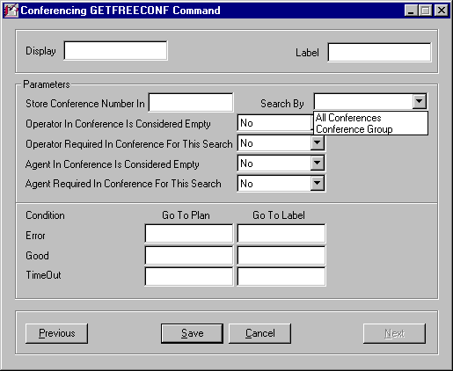
Figure 4-12. GETFREECONF Command Screen.

Parameters

The Store Conference Number In field is for storing the Plan Variable Name (without brackets). This will be used to compare with another variable so that callers with a common thread, such as a PIN or category, will find the same conference number.

In the Search By parameter field a drop-down box allows the choices of All Conferences or Conference Group. The Conference Group is set up on the IVR with the conferencing configuration utility and is not done in a Plan command.

You have the choice of defining a conference empty with or without the operator in the conference using the Operator In Conference Is Considered Empty field; enter “Yes” or “No”.

In the Operator Required In Conference For This Search field, select “Yes” or “No” from the drop-down box. If an operator is required, the conference is considered empty with one present and this super-cedes the previous parameter where the choice is whether or not the conference is empty with an operator in the conference.

Note: There is a distinction between an operator and an agent (topic of the next two parameters). An operator is more an administrator and has access to the Matrix² Conferencing Windows screens. The operator is able to manipulate callers from conference to conference, make them coaches or pupils, mute them and/or remove them from the conferencing Plan. An agent can log in to a conference and move to other conferences from a special Plan for agents but does not have a Windows screen or administrative capabilities.

If the criteria for the Plan recognize agents and/or operators as separate entities, the presence of an agent in a conference can make it empty or not empty based on how you set this parameter. From the drop-down box, select “Yes” or “No” in the Agent In Conference Is Considered Empty field.

If in the Agent Required In Conference For This Search field you select “Yes”, the conference is considered empty with the agent present and the previous parameter is not required. A “No” causes the Agent In Conference Is Considered Empty parameter to be relevant.

Conditions

There are three conditions in the GETFREECONF command. These are: Error, Good and TimeOut. Each is discussed in the following paragraphs. To avoid redundancy, the steps for each condition are mentioned here. If the condition exists, enter the Plan Name in the Go To Plan field and the Label Name in the Go To Label field. If the Step is in the same Plan, leave the Go To Plan field empty.

If there is an Error the source could be that the Plan has not been written correctly, there is a problem between the IVR and the switch, there is a database problem or other possibilities.

The Good condition is reserved for future use.

The TimeOut Condition in this command is based on the Time Limit (sec) parameter in the PUTINCONF command.

4-4. NAMECONF Command

This command provides the capability of associating a name to a conference number. Conference numbers are set up on the IVR using the Matrix² Conferencing utility; having a conference name can assist in analysis, troubleshooting or reports. Figure 4-13 is the NAMECONF command screen.

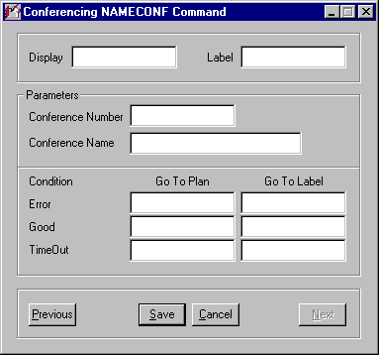
Figure 4-13. NAMECONF Command Screen.

The Display field is for uniquely identifying the command and can be viewed on the Runtime Line Display while the call progress is observed. With the Label field filled in you can jump to this command with a JUMPOUT or other Program Flow command from any command in the Plan (or another Plan) as long as it is unique.

Parameters

The first parameter is the Conference Number that is based on the setup in the Matrix² Conferencing utility. Access to a Conferencing Windows terminal will show the configured conferences and their assigned numbers; there may be as many as 240. Enter the Conference Number here; in all likelihood, this will be a Plan Variable (in brackets) based on a variable assigned in a SETVAR command where the value is an expression or is derived from the MySQL database.

The Conference Name parameter field contains the name assigned to the Conference Number. This cannot be hard-coded or fixed as the Conference Number varies. Use a Plan Variable (in brackets) that has been set in a SETVAR command as a database entry or an expression.

Conditions

There are three conditions in the NAMECONF command. These are: Error, Good and TimeOut. Each is discussed in the following paragraphs. To avoid redundancy, the steps for each condition are mentioned here. If the condition exists, enter the Plan Name in the Go To Plan field and the Label Name in the Go To Label field. If the Step is in the same Plan, leave the Go To Plan field empty.

If there is an Error the source could be that communication to the Matrix² daemon has failed. While this is a rare occurrence, providing this condition ensures that the Plan does not “hang” and freeze the line; the flow will continue starting with the Label designated in the Go To Label field.

The Good condition is reserved for future use.

The TimeOut Condition in this command is also based on a lack of communication to the Matrix² daemon; in this case a system timeout will be the cause. Again, this condition gives insurance that the line will not freeze and the Plan flow is maintained.

4-5. NUMOFCONFEREES Command

In this command, many Plan Variables are possible for storage of a number of conferencing statistics. The NUMOFCONFEREES command is also used to find how many callers are in a conference – especially how many are empty. Figure 4-14 is the NUMOFCONFEREES command screen.

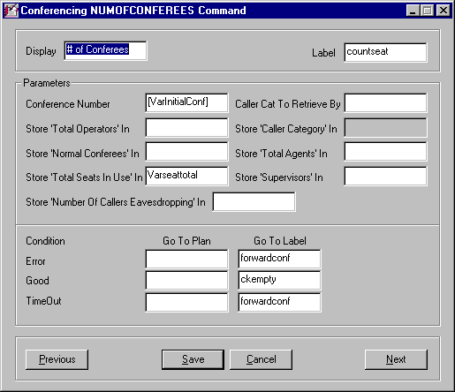
Figure 4-14. NUMOFCONFEREES Command Screen.

The Display field is for using a unique mnemonic for the command and its purpose and can be viewed on the Runtime Line Display while the call progress is watched. With the Label field filled in you can jump to this command with a SELECT or other Program Flow command from any Step in the Plan as long as the Label is unique.

Parameters

The Conference Number, as was discussed in Section 4-4, NAMECONF command, must be in the form of a Plan Variable (with brackets) since the Conference Number varies and a fixed number will not work. The Plan Variable can be based on an expression or database information.

In the PUTINCONF command is a parameter named Category; this is a fixed number to represent categories such as normal callers, agents, operators and supervisors as an example. This depends on your conferencing setup. In this command, the parameter Caller Cat To Retrieve By must correlate to the entry in the Category parameter field. As there may be more than one category, the Plan must be written so that different branches have groups of NUMOFCONFEREES and PUTINCONF and other related commands that revolve around the same category.

Note: The next seven parameters require Plan Variables as entries. These are not used in this command but at a later portion of the Plan. Since they are simply the Variable names, there are no brackets required for these entries.

The system knows at every moment how many operators have dialed in; this is through a linkage to the Matrix² Conferencing software. To create a “data bucket” for the number of operators at a given time, enter the Plan Variable name in the Store ‘Total Operators’ In parameter field.

To provide a storage bin for the associated category for this command (and others like it in the Plan), enter the variable name in the Store ‘Caller Category’ In field. Make sure that all NUMOFCONFEREES commands in the Plan use the same variable name.

In the Store ‘Normal Conferees’ In parameter field enter the Plan Variable name of your choice. Normal Conferees refers to all callers who are not operators or agents.

As above, select a variable name and enter it in the Store ‘Total Agents’ In field; this holds the number of agents at a given time.

Adding the Agents, Operators, Normal Conferees and Supervisors will yield the total number of seats used at a given time. Enter this Plan Variable name in the Store ‘Total Seats In Use’ In parameter field.

Another caller category can be Supervisor. Enter the variable name for this category in the Store ‘Supervisors’ In field.

Supervisors and Operators can eavesdrop; eavesdroppers are not a new category but an action that authorized callers are taking. In the Store ‘Number Of Callers Eavesdropping’ In field, enter the appropriate Plan Variable name.

Conditions

There are three conditions in the NUMOFCONFEREES command. These are: Error, Good and TimeOut. Each is discussed in the following paragraphs. To avoid redundancy, the steps for each condition are mentioned here. If the condition exists, enter the Plan Name in the Go To Plan field and the Label Name in the Go To Label field. If the Step is in the same Plan, leave the Go To Plan field empty.

If there is an Error the source could be that communication to the Matrix² daemon has failed. While this is a rare occurrence, providing this condition ensures that the Plan does not “hang” and freeze the line; the flow will continue starting with the Label designated in the Go To Label field.

The Good condition is reserved for future use.

The TimeOut Condition in this command is also based on a lack of communication to the Matrix² daemon; in this case a system timeout will be the cause. Again, this condition gives insurance that the line will not freeze and the Plan flow is maintained.

4-6. PLAYINCONF Command

This command is not only for playing messages in the conference but also playing prompts just to the caller. As an example, just before the caller enters the conference, a message may be played such as “You are about to enter conference number five” (or a conference name if you set it up that way). The message played in the conference may be something like “Caller 1004 is about to enter the conference”. Figure 4-15 is the PLAYINCONF command screen.

The Display field is for uniquely identifying the command and can be viewed on the Runtime Line Display while the call progress is observed. With the Label field filled in you can jump to this command with a JUMPBACK or other Program Flow command from any command in the Plan (or another Plan) as long as it is unique.

Parameters

The first parameter is the Conference Number that is based on the setup in the Matrix² Conferencing utility. There may be as many as 240 Conference Numbers. Enter the Conference Number here; this will be a Plan Variable (in brackets) based on a variable assigned in a SETVAR command where the value is an expression or is derived from the MySQL database.

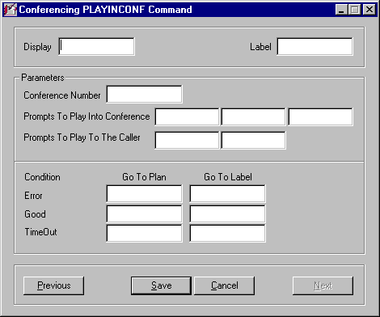
Figure 4-15. PLAYINCONF Command Screen.

Three fields are available for the messages in the Prompts To Play In Conference parameter. Voice files and/or Plan Variables may be used. As an example, let us say that the first field contains a variable, [CallerID], which provides the ID given to the caller based on the line number s/he called in on. The second field could be a fixed voice file, enter, which has the script “. . . is about to enter the conference”. Certainly on of the fields must contain a Plan Variable since each caller’s identity is unique.

In the Prompts To Play To Caller fields a message is played to the caller prior to going into the conference. In this case we can have the first field be a fixed voice file, GetReady, that has the script “You are about to enter conference number . . .” and the second field can have the variable [ConfNum].

Conditions

There are three conditions in the PLAYINCONF command. These are: Error, Good and TimeOut. Each is discussed in the following paragraphs. To avoid redundancy, the steps for each condition are mentioned here. If the condition exists, enter the Plan Name in the Go To Plan field and the Label Name in the Go To Label field. If the Step is in the same Plan, leave the Go To Plan field empty.

If there is an Error the source could be that communication to the Matrix² daemon has failed. While this is a rare occurrence, providing this condition ensures that the Plan does not “hang” and freeze the line; the flow will continue starting with the Label designated in the Go To Label field.

The Good condition is reserved for future use.

The TimeOut Condition in this command is also based on a lack of communication to the Matrix² daemon; in this case a system timeout will be the cause. Again, this condition gives insurance that the line will not freeze and the Plan flow is maintained.

4-7. PLAYTONECONF Command

This is a very simple command. You have the option of having a tone played (often instead of an announcement message) and can set that up for your conference(s) here. By not using the command or leaving the parameter field blank (giving you the option to enable the tone later) the tone will not play. Figure 4-16 shows the PLAYTONECONF command screen.

The Display field is for uniquely identifying the command and can be viewed on the Runtime Line Display while the call progress is observed. With the Label field filled in you can jump to this command with a JUMPBACK or other Program Flow command from any command in the Plan (or another Plan) as long as it is unique.

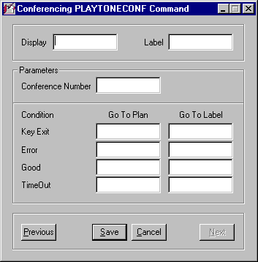
Figure 4-16. PLAYTONECONF Command Screen.

Parameters

There is one parameter in this command, Conference Number. If there is only on conference being enabled for the tone, you can enter a single conference number. If there is more than one, enter a Plan Variable that will account for all conference numbers to be enabled (in brackets).

Conditions

There are four conditions in the PLAYTONECONF command. These are: Key Exit, Error, Good and TimeOut. To avoid redundancy, the steps for each condition are mentioned here. If the condition exists, enter the Plan Name in the Go To Plan field and the Label Name in the Go To Label field. If the Step is in the same Plan, leave the Go To Plan field empty.

If the caller hits the exit key set up in the Matrix2 Conferencing utility, then this condition will be present.

If there is an Error the source could be that communication to the Matrix² daemon has failed. While this is a rare occurrence, providing this condition ensures that the Plan does not “hang” and freeze the line; the flow will continue starting with the Label in a Go To Label field or whatever command follows.

The Good condition is reserved for future use.

The TimeOut Condition in this command is also based on a lack of communication to the Matrix² daemon; in this case a system timeout will be the cause. Again, this condition gives insurance that the line will not freeze and the Plan flow is maintained.

4-8. PUTINCONF Command

This is a very versatile command with several optional features that work with the MCCT Matrix² Conferencing Package. In Figure 4-17, the fields that can be filled in provide a variety of options for entering a conference and for what can occur while in the conference. These are defined in the paragraphs that follow.

The first box, Display, at the top left is for displaying this specific command display name in the Runtime Line Display to observe the call progress for the line. The box at the top right is the Label used for accessing this command from other commands not in the sequential flow. These include Program Flow commands such as GOTO, SELECT, JUMPBACK and the rest. Figures 4-17 through 4-19 show the PUTINCONF command screen as it comes up and with the Caller Attributes and Special Flags drop-down boxes shown.

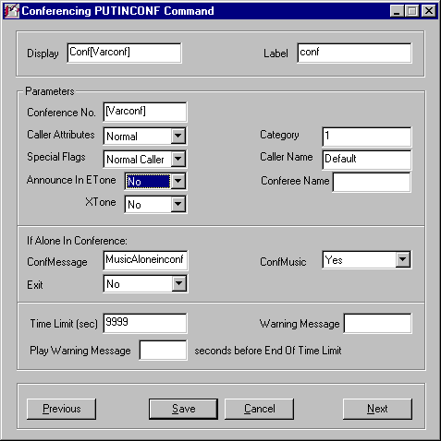
Figure 4-17. PUTINCONF Command Fields.

Parameters

The first box is Conference No.; this can contain a defined conference number, e.g., “1”, “2”, etc. It can also contain a User Variable, as is the case in Figure 4-17. The conference number is shown as [Varconf]; Matrix² sees anything in brackets as a variable usable in the command. Since this is not a system variable (These are discussed in Chapter 15 – Administration) it must be defined somewhere in the Plan.

The next parameter – Caller Attributes – sets the caller role as is shown in the drop-down box in Figure 4-18.

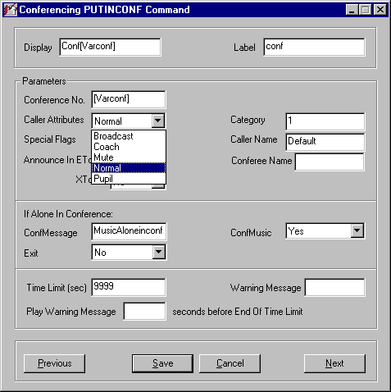
Figure 4-18. PUTINCONF Command Screen with Caller Attributes Drop-down Box.

A caller may enter a conference normally, which allows speaking and listening as is typical in a conference environment. Another option is to bring people into a conference to listen only with the Mute feature. With the Coach attribute the caller will enter conf-erences as the speaker where everyone can hear him but they cannot hear each other.

This then leads to the Pupil mode where callers enter various conferences as pupils and all can hear the coach but cannot talk to each other. Lastly, callers can enter any conference in the broadcast mode where everyone on the system can hear them. This can be set up sending a message such as an advertisement, notice or some other broadcast.

The Category parameter field is intended for counting caller categories entering conferences. Only the caller with the defined category will be placed in the particular (Step #) PUTINCONF command via a Select command, for example. These will be collectively counted in the Store ‘Caller Category’ In parameter in the NUMOFCONFEREES.

The Special Flags box is for identifying the caller as one of three types: a) Normal Caller, b) Operator or c) Agent. Figure 4-19 shows the drop-down box for the Special Flags parameter.

Normal Caller status requires no explanation. Flagging the caller as an Operator indicates that this PUTINCONF command is for conference monitors (Operators) to be placed in their appropriate conference. A caller who is an Agent is dialing in on an application associated with a Call Center where agents are put in conferences to serve some business purpose.

In the Caller Name box, Default is filled in when the command is first brought up. You may leave it as is or type in a name (e.g., Agent or Operator) or you might put in a User Variable. Possible User Variables are: Port Number, ANI or some other caller defined data. The Announce in ETone and XTone (Yes or No) are the options to have a tone heard by existing conferees when a caller Enters or Exits a conference.

The Conferee Name is associated with the recorded voice of the caller’s name. Before a person enters a conference, s/he is prompted to record his/her name. Entering a User Variable, e.g., [Rec_Name], allows the recorded name to be used in an “announce” message; this is an option. An example would be: “John Doe has just entered the conference”.

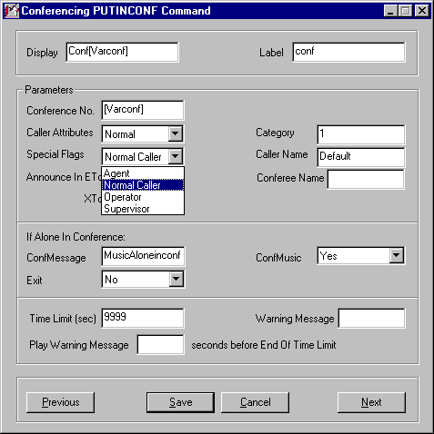
Figure 4-19. PUTINCONF Command Screen with Special Flags Drop-down Box.

If Alone In Conference

To cover those times when a caller is the first to enter a confer-ence and must wait until the next caller enters, these parameters should be defined: ConfMessage, ConfMusic and Exit.

The ConfMessage field is for a text (TTS) or recorded message that is played to the first person in a conference. It should tell the caller that there is no one else in the room but someone will be entering shortly. In the ConfMusic box you enter either a “Yes” or a “No” using the drop-down box. This determines whether or not music is played while the conferee is alone in the conference. There is also the option to cause the caller to leave the conference if it is empty using a “Yes” or “No” in the Exit box. This is only used if it is required that an Agent or Operator be present before anyone enters the conference.

The Time Limit(sec) defines the maximum time a caller can be in the conference. Typically this value will be in the 60 to 300 second range but there may be instances where a short time needs to be set; this value can be set as high as the MAXTIME System Variable discussed in Chapter 15 – Administration. The Warning Message is made to let the caller know that s/he has “N” minutes left in the conference (only the caller hears this). This gives them the opportunity to “wrap things up”. The Play Warning Message [ ] Seconds Before End of Time Limit field defines how much notice the caller is given.

4-9. SC1ON1 Command

In a similar fashion to the Direct1on1 commands, SC1ON1 sets a one-on-one connection between two callers. The difference is that the two callers agree through a request and acceptance that they would like to talk privately. There are several parameters that set time limit, message and exit values; these can be seen in Figure 4-20.

The Display field is for uniquely identifying the command and can be viewed on the Runtime Line Display while the call progress is observed. With the Label field filled in you can jump to this command with a JUMPBACK or other Program Flow command from any command in the Plan (or another Plan) as long as it is unique.

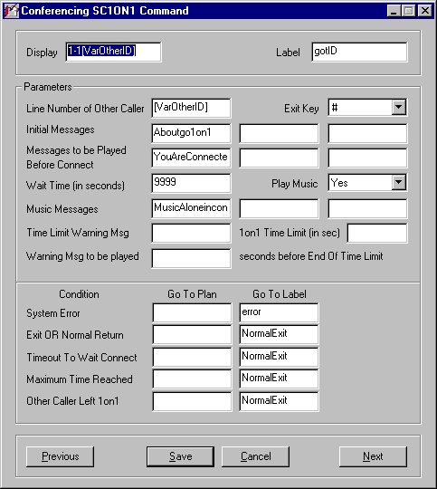
Figure 4-20. SC1ON1 Command Screen.

Parameters

In the Line Number of Other Caller field, a Plan Variable should be used (in brackets since it is used in the command) because the line number will vary for each “Other Caller”. This ID will be obtained from another command such as a GETDTMF.

The Exit Key is the key used for either caller to exit the one-on-one; this will have been told to them in the Initial Messages prompt(s). Figure 4-21 shows the drop-down of the available keys (A – D are for special PBX phones only); select the key to correspond with the voice prompt.

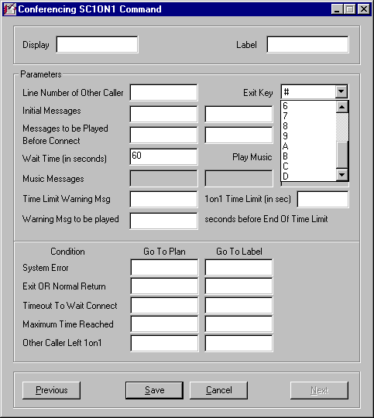
Figure 4-21. SC1ON1 With Key Drop-down Box.

The first of several message groups in this command, the Initial Messages parameter fields are for providing instructions to the caller regarding the one-on-one connection. As an example, the Exit Key will be given and any other pertinent information regarding the connection. These can be generic messages and thus be fixed voice files.

In the Messages to be Played Before Connect boxes, a mix of fixed voice files and Plan Variables (in brackets). An example of this would be a voice file (enter1on1) followed by a variable ([VarCallerID]) where enter1on1 is: “you are about to be connected with . . .” and [VarCallerID] is the connection party’s ID.

Due to system activity and caller activity, a connection may take a while to be made. It is, therefore, a good idea to set a time limit on the waiting period for a connection. In the Wait Time (in seconds) parameter field, enter the amount of time you think will be optimal for a waiting period that avoids setting up impatience on the caller’s part.

The Play Music parameter drop-down box has two options: “Yes” or “No”. Selecting “Yes” allows music to be played if there are music files in the Music Messages parameter field(s). Selecting “Yes” also enables the message boxes as shown in Figure 4-20; a “No” choice causes the Music Messages fields to be grayed out as shown in Figure 4-22.

Music may be played in the Music Messages parameter fields if ”Yes” has been selected in the Play Music field. If you have selected the Wait Time (in seconds) parameter, you may have one music message of 60 seconds, two music messages of 30 seconds or three messages lasting 20 seconds each. These may all be the same message (on the multiple messages) that rolls from one into the other. Be sure that no voice prompts are played here as there are other parameters to be used for voice.

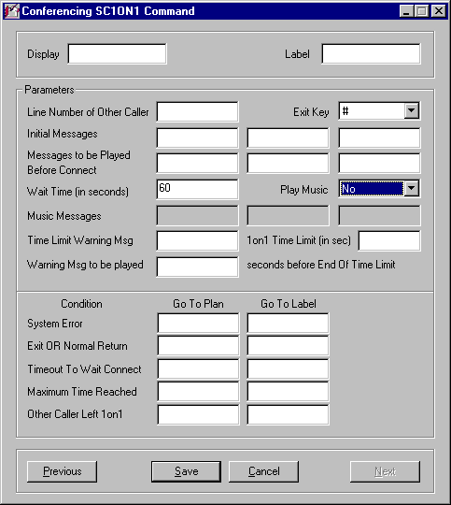
Figure 4-22. SC1ON1 With Music Messages Fields Grayed Out From a Play Music = No Selection.

In the Time Limit Warning Msg field, enter voice prompt name to be played that warns the caller(s) of how much time is left for their one-on-one connection. This can be a fixed voice file that foretells the time in seconds that is entered in the Waiting Message to be played [ ] seconds before End Of Time Limit parameter.

Should you decide to set a time limit on the one-on-one connection, this can be entered in the 1on1 Time Limit (in sec) parameter field. Leaving this field blank will impose no limit and all related parameters should also be left blank.

Enter the time that the Time Limit Warning Msg is to be played in the Warning Msg to be played [ ] seconds before End Of Time Limit parameter field. This should be 10 or 15 seconds to give the callers a chance to wrap things up.

Conditions

There are five conditions in the SC1ON1 command. These are: System Error, Exit OR Normal Return, TimeOut to Wait Connect, Maximum Time Reached and Other Caller Left 1on1. Each is discussed in the following paragraphs. To avoid redundancy, the steps for each condition are mentioned here. If the condition exists, enter the Plan Name in the Go To Plan field and the Label Name in the Go To Label field. If the Step is in the same Plan, leave the Go To Plan field empty.

The System Error condition results from a potential daemon communication problem, network problem and so on. Having this condition in place prevents the line that this caller came in on from hanging; a graceful exit is ensured.

An Exit is a caller created condition by pressing the appropriate key and a Normal Return means that the other caller pressed the exit key at the end. Enter the next Step to go to by typing the Label Name for that Step in the Exit OR Normal Return field.

If the Wait Time (in seconds) field is surpassed, enter the Label Name for the next Step in the Timeout To Wait Connect field.

The same is true (as above) for the Maximum Time Reached condition. In this case, neither caller hit the exit key.

If the other caller leaves the one-on-one early, enter the Label Name in the Other Caller Left 1on1 field.

